WGU C951

Task 3

MACHINE LEARNING PROJECT PROPOSAL

Steven Bennett

Student ID #003761827

January 4, 2024

Table of Contents

A. Project Overview....................................................................................................................pg# A.1. Organizational Need ......................................................................................................... pg# A.2. Context and Background..................................................................................................... pg# A.3. Outside Works Review ...................................................................................................... pg# A.4. Solution Summary............................................................................................................. pg# A.5. Machine Learning Benefits................................................................................................ pg# B. Machine Learning Project Design......................................................................................... pg# B.1. Scope ................................................................................................................................. pg# B.2. Goals, Objectives, and Deliverables ................................................................................. pg# B.3. Standard Methodology ..................................................................................................... pg# B.4. Projected Timeline ............................................................................................................. pg# B.5. Resources and Costs........................................................................................................... pg# B.6. Evaluation Criteria ............................................................................................................ pg# C. Machine Learning Solution Design....................................................................................... pg# C.1. Hypothesis.......................................................................................................................... pg# C.2. Selected Algorithm............................................................................................................. pg# C.2.a Algorithm Justification..................................................................................................... pg# C.2.a.i. Algorithm Advantage ................................................................................................... pg# C.2.a.ii. Algorithm Limitation ................................................................................................... pg# C.3. Tools and Environment ...................................................................................................... pg# C.4. Performance Measurement................................................................................................. pg# D. Description of Data Sets ....................................................................................................... pg# D.1. Data Source ....................................................................................................................... pg# D.2. Data Collection Method...................................................................................................... pg# D.2.a.i. Data Collection Method Advantage............................................................................... pg# D.2.a.ii. Data Collection Method Limitation ............................................................................. pg# D.3. Data Normalization............................................................................................................. pg# D.4. Data Security....................................................................................................................... pg# References.................................................................................................................................. pg#

**A. Project Overview**

Recognizing that the safety of our drivers as well as the safety of everyone on the road as a top priority, the Research & Development Team at WeGovU Logistics proposes an innovative software solution designed to identify signs of WeGovU driver drowsiness by pulling real-time images from existing on-board driver cameras and assessing driver alertness during operation. Successful development and deployment of this solution would allow further integration of an alert system, enabling proper support channels to respond and provide potential crash intervention. This would enable WeGovU Logistics to mitigate risks associated with drowsy driving, decrease the number of crashes, and improve overall road safety.

**A.1. Organizational Need**

WeGovU Logistics faces a significant challenge in dealing with the consequences of driver drowsiness, a plaguing issue in the transportation sector. To effectively address this challenge, the Research & Development team seeks the integration of innovative and effective drowsiness detection software, seamlessly blending with existing on-board driver cameras. This solution is designed to mitigate accidents stemming from fatigue not only prioritizing driver and traffic safety, but also reinforcing regulatory compliance, optimizing operational efficiency, and reducing costs linked to accidents and insurance. By proactively identifying and addressing signs of drowsiness through the integration of this software into existing onboard driver cameras, WeGovU Logistics aspires to cultivate a safer, more regulatory-compliant, and cost-efficient operational environment. This proposal outlines the imperative adoption of drowsiness detection software, strategically addressing both executive concerns and the practical needs of our tradespeople on the front lines.

**A.2. Context and Background**

WeGovU Logistics has been deeply rooted in the transportation sector for nearly 3 decades. The organization has a track record of proactively and intelligently investing in solutions that benefit the company and the community. The proposed software solution integrates machine learning to facilitate a strategic response to combat drowsy driving, which has historically been a plaguing issue in the industry.

How serious is drowsy driving? The AAA Foundation for Traffic Safety estimated a total of 328,000 crashes occurred due to driver drowsiness, accounting for 21% of all U.S. vehicle crashes. Out of those, approximately 109,000 resulted in injury and 6,400 were fatal. The National Highway Traffic Safety Administration estimated in 2021 that the cost of fatigue-related crashes resulting in injury or fatality cost society in general approximately $109 billion annually, not including property damage (National Safety Council).

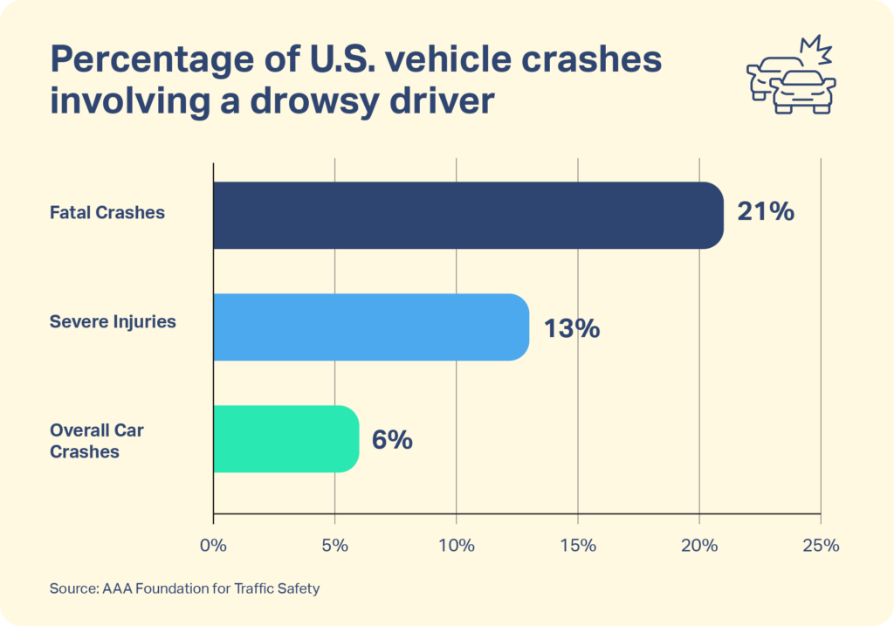

Research reveals that although a significant majority of Americans acknowledge the peril of driving while drowsy (94.8%), nearly 19% of the surveyed individuals admitted to engaging in drowsy driving at least once within the past 30 days. Additional studies from AAA Foundation research in 2023 indicate that while drivers may recognize their drowsiness, they often underestimate its severity. Approximately 75% of individuals who believed they were only mildly fatigued were determined to be moderately or severely sleepy. Alarmingly, out of those drivers who acknowledged their own fatigue, 75% opted to continue driving instead of pulling over for a break (Sleep Foundation).

Given the reported increase in police-reported traffic crashes from 5.25 million in 2020 to 6.10 million in 2021 (Stewart), it is reasonable to infer that the total number of crashes attributable to drowsy driving may have experienced a parallel rise. This concerning trend, coupled with a 16% increase, undoubtedly exacerbates an already problematic situation.

After assessing multiple strategies to address drowsy driving, WeGovU Logistics seeks to effectively minimize this risk by incorporating the proposed software solution. Notably, last-minute standalone interventions such as rumble strips have demonstrated an estimated 30-50% decrease in road departure crashes in rural settings (National Highway Traffic Safety Administration). WeGovU hopes to achieve similar rates by utilizing this solution as an earlier warning system, allowing more time for drivers to be alerted and corrective actions to be taken. With a workforce exceeding 11,000 drivers, WeGovU recorded 133 accidents in 2021, including 9 with fatalities. The implementation of an advanced early warning detection system is anticipated to further diminish the incidence of crashes attributed to driver drowsiness, improving driver and highway safety, and decreasing operational costs linked to crashes and insurance. Using the data from the National Safety Council, even a modest 5% decrease in crashes that involve WeGovU 2021 would save over $2 million in total costs as well as contribute to employee and community safety.

**A.3. Outside Works Review**

Our strategy is straightforward: utilize what resources are available. In our case, we possess onboard cameras and aim to enhance driver and community safety by detecting signs of driver drowsiness. Our process began with an examination of machine learning methods suitable for optimizing our existing onboard camera system. We meticulously refined our options until we identified the most fitting solution.

The article "10 Machine Learning Methods That Every Data Scientist Should Know" (Castanon) played a crucial role in establishing a foundational understanding of machine learning methods. This resource facilitated a swift narrowing down of potential methods by outlining the tasks each approach excels at. Simply put, we confirmed that the challenge at hand involves image classification, necessitating a supervised deep-learning neural network.

Recognizing that many solutions already exist for similar endeavors, we opted to adapt existing models rather than reinventing the wheel. Once we established the fundamental path for our solution, we delved into existing solutions to glean insights into the most efficient ways to employ machine learning for monitoring and identifying drowsy drivers.

A review published on September 13, 2023, titled “A Deep-Learning Approach to Driver Drowsiness Detection” (Ahmed et al. 65) allowed us to further refine our approach by evaluating several other solutions mentioned in their work. Like their approach, we decided to utilize a public dataset from Kaggle.com for training and testing purposes, employing supervised classification.

In March 2020, the article “Driver Drowsiness Detection System using Machine Learning Algorithms” (Ramalingam et al.) presented a simple and effective solution, relying solely on the Computer Vision method. Applications leveraging computer vision incorporate input from various technologies, including sensing devices, artificial intelligence, and deep learning, to mimic the human vision system. These applications utilize algorithms trained on vast visual data to recognize patterns and apply them to discern the content of other images ("What is Computer Vision?").

**A.4. Solution Summary**

Based on the observed success rates, WeGovU is optimistic that a customized approach, employing comparable techniques, will yield favorable outcomes. Our approach entails using computer vision methodologies to analyze images taken by onboard cameras, utilizing a deep learning neural network to categorize the images and ascertain whether the driver is experiencing drowsiness.

**A.5. Machine Learning Benefits**

By utilizing Kaggle.com as a training and testing dataset, our solution utilizes computer vision and deep learning to classify drivers as drowsy or not. This approach enhances safety by addressing drowsy driving risks and providing our solution with a good baseline that continues to learn over time. The benefits of machine learning far outweigh the option of developing support staff to monitor approximately 11,000 drivers in real-time, considering the support staff would also be vulnerable to human error and distractibility. The solution enhances operational safety, leading to cost savings and a competitive edge. Post-deployment, ongoing improvement strategies include refining algorithms based on real-world feedback, updating training data, and incorporating advancements in machine learning technologies.

**B. Machine Learning Project Design**

**B.1. Scope**

The scope of this project is to develop a machine learning solution to detect signs of drowsiness by analyzing images captured from existing onboard cameras. This includes:

* Collecting the image dataset for training and testing
* Manually categorizing and verifying images as drowsy or not drowsy
* Implementing an image classification system to identify images as drowsy or not drowsy
* Calibrating the image classification system to achieve the desired success rate

Not included in this solution (but not limited to) are the following:

* Integrating an interface with the onboard satellite communications system to alert the dispatcher of driver status. This is due to the licensing agreement with the satellite communications service provider.

**B.2. Goals, Objectives, and Deliverables**

Goals

* Productivity goals
* Cost goals
* Improvement goals

Objectives

* Specific, quantifiable (% uptime, accuracy, throughput) ***also used in B6

Deliverables

* ML model, hardware/software, data sources

**B.3. Standard Methodology**

Describe what methodology is used and how it will be applied to the proposed project. Please view an example below.

Development will follow the {SEMMA, CRISP-DM, etc} methodology.

• Sample:

• Explore:

• Modify:

• Model:

• Assess:

**B.4. Projected Timeline**

Date 1 – The proposal is accepted …

Date 2 – A technical proof of concept is presented.

Date 3 – Submitted for review…

Date 4 – Deliverables

Date 5 – Delivered

**Sprint Schedule**

|  |  |  |  |
| --- | --- | --- | --- |
| **Sprint** | **Start** | **End** | **Tasks** |
| 1 | Date | Date |  |
| 2 | Date | Date |  |
| 3 | Date | Date |  |
| 4 | Date | Date |  |

**B.5. Resources and Costs**

|  |  |  |
| --- | --- | --- |
| **Resource** | **Description** | **Cost** |
|  |  |  |
|  |  |  |
|  |  |  |
|  | **Total** | (Total cost) |

**B.6. Evaluation Criteria**

Describe the criteria used to evaluate and measure the success of the completed project.

|  |  |
| --- | --- |
| **Objective** | **Success Criteria** |
| (Ease of Use) |  |
| (User error rate reduction) |  |
| (Algorithm Efficiency) |  |

**C. Machine Learning Solution Design**

**C.1. Hypothesis**

Describe the problem and solution that aligns with the research question or organizational need.

**C.2. Selected Algorithm**

Describe algorithm used.

**C.2.a Algorithm Justification**

Cite sources and reason for algorithm selection.

**C.2.a.i. Algorithm Advantage**

Describe the degree of confidence.

**C.2.a.ii. Algorithm Limitation**

Describe the limitation.

**C.3. Tools and Environment**

For example: Describe the operating systems used, the API, libraries and programming language used, and identify any third-party code used.

**C.4. Performance Measurement**

Describe how quality and performance will be measured.

**D. Description of Data Sets**

**D.1. Data Source**

Describe where the data source will be extracted from.

**D.2. Data Collection Method**

Describe how the data collection functions.

**D.2.a.i. Data Collection Method Advantage**

Describe the positive outcomes of the data collection method.

**D.2.a.ii. Data Collection Method Limitation**

Describe the limitations.

**D.3. Quality and Completeness of Data**

Explain how the data will be prepared for the algorithms from part C2.

**D.4. Precautions for Sensitive Data**

Describe behaviors when working with communicating about sensitive data.

**References**

National Safety Council. "Prevalence of Drowsy Driving Crashes." National Safety Council, n.d., <https://www.nsc.org/road/safety-topics/fatigued-driver?#:~:text=Prevalence%20of%20Drowsy%20Driving%20Crashes&text=A%20study%20by%20the%20AAA,and%20about%206%2C400%20were%20fatal>.

Stewart, T. "Overview of Motor Vehicle Traffic Crashes in 2021." Report No. DOT HS 813 435, National Highway Traffic Safety Administration, April 2023.

Sleep Foundation. "Drowsy Driving Is a Factor in 21 Percent of Fatal Crashes." Sleep Foundation, November 6, 2023, <https://www.sleepfoundation.org/sleep-news/drowsy-driving-is-a-factor-in-21-percent-of-fatal-crashes>.

National Highway Traffic Safety Administration. "Drowsy Driving." NHTSA, n.d., <https://one.nhtsa.gov/people/injury/drowsy_driving1/drowsy.html#:~:text=These%20rumble%20strips%20placed%20on,by%2030%20to%2050%20percent>.

Castañón, Jorge. "10 Machine Learning Methods That Every Data Scientist Should Know." Towards Data Science, Medium, 1 May 2019, <https://towardsdatascience.com/10-machine-learning-methods-that-every-data-scientist-should-know-3cc96e0eeee9>.

Ahmed, M.I.B., et al. "A Deep-Learning Approach to Driver Drowsiness Detection." *Safety*, vol. 9, no. 3, 2023, p. 65. <https://doi.org/10.3390/safety9030065>.

Ramalingam, V.V., Shivani Sheth, and Aditya Singhal. "Driver Drowsiness Detection System using Machine Learning Algorithms." *International Journal of Recent Technology and Engineering (IJRTE)*, vol. 8, no. 6, March 2020, [www.ijrte.org](http://www.ijrte.org/).

"What is Computer Vision?" Microsoft Azure, n.d., [https://azure.microsoft.com/en-us/resources/cloud-computing-dictionary/what-is-computer-vision/?ef_id=_k_caf0aca35e551c1e41ecc93af8128d07_k_&OCID=AIDcmme9zx2qiz_SEM__k_caf0aca35e551c1e41ecc93af8128d07_k_&msclkid=caf0aca35e551c1e41ecc93af8128d07#object-clssification](https://azure.microsoft.com/en-us/resources/cloud-computing-dictionary/what-is-computer-vision/?ef_id=_k_caf0aca35e551c1e41ecc93af8128d07_k_&OCID=AIDcmme9zx2qiz_SEM__k_caf0aca35e551c1e41ecc93af8128d07_k_&msclkid=caf0aca35e551c1e41ecc93af8128d07#object-classification) .